Project Design Phase-II
Data Flow Diagram & User Stories

Date | 26-05-2025
Team ID | LTVIP2025TMID53011
Project Name | HouseHunt: Finding Your Perfect Rental Home
Maximum Marks | 4 Marks
📊 Data Flow Diagram (DFD) – HouseHunt
A Data Flow Diagram (DFD) for HouseHunt illustrates how different users—renters, property owners, and admins—interact with the system and how data moves across its core components. It provides a high-level overview of how information flows between user actions, system processes, and data storage.
🧩 Key Elements Covered in the DFD:
- User Interactions:
  - Renters can register/login, search properties, send booking inquiries, and manage saved listings.
  - Property owners can register/login, add or update property listings, and respond to inquiries.
  - Admins can log in, verify listings, manage user activity, and promote trusted properties.
- Core Processes:
  - User Authentication: Login and role-based access
  - Property Search & Filter: Querying listings based on user filters
  - Booking & Inquiry System: Sending and managing inquiry requests
  - Listing Management: CRUD operations on rental properties by owners
  - Admin Controls: Approving listings, managing user roles, and promoting listings
- Data Stores:
  - Users Collection: Stores renter, owner, and admin accounts
  - Properties Collection: Stores all property listings with details
  - Bookings Collection: Stores inquiries, messages, and booking status

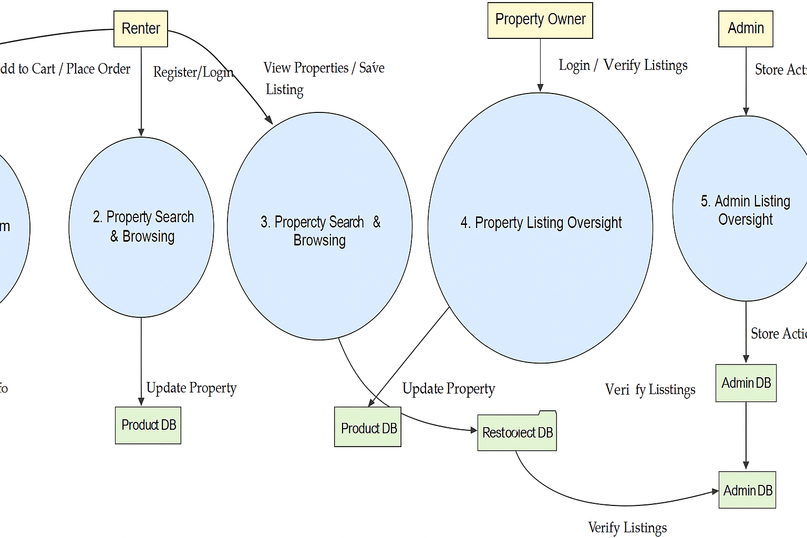

User Stories

User Story Table – Freelance Finder
User Type | Functional Requirement (Epic) | User Story / Task | Acceptance Criteria | Priority | Release
Renter | User Authentication | As a renter, I can sign up and log in securely. | Account created and token issued on login. | High | Sprint-1
Renter | Property Browsing | As a renter, I can view categories and browse rental listings. | Properties shown with categories on homepage. | High | Sprint-1
Renter | Listing Viewing & Favorites | As a renter, I can view details and save listings to favorites. | Saved listings reflected in renter’s dashboard. | High | Sprint-2
Renter | Booking Inquiry | As a renter, I can send inquiries to property owners. | Inquiry saved and visible to both renter and owner. | High | Sprint-2
Renter | Inquiry Tracking | As a renter, I can track responses to my inquiries. | Replies from owners shown in dashboard. | Medium | Sprint-2
Property Owner | Dashboard Login | As an owner, I can log in and access my dashboard. | Redirected to dashboard with property list. | High | Sprint-3
Property Owner | Property Management | As an owner, I can add/edit/delete rental properties. | Property data updates in database and reflects in listings. | High | Sprint-3
Property Owner | Inquiry Management | As an owner, I can view and respond to rental inquiries. | Responses sent and shown in renter dashboard. | Medium | Sprint-3
Admin | Admin Login | As an admin, I can log in and view all platform activity. | Admin dashboard loads with user and listing statistics. | High | Sprint-4
Admin | Promote Listing | As an admin, I can promote listings to appear on the homepage. | Promoted listings are shown in "Featured" section on frontend. | Medium | Sprint-4

